**Workshop Produksi Game**



Disusun Oleh :

Apriana Pramadita 4210161004

Gusti Zainokta 4210161009

Muhammad Aditya Devara Naufal 4210161013

**PROGRAM STUDI TEKNOLOGI GAME**

**DEPARTEMEN TEKNOLOGI MULTIMEDIA KREATIF**

**POLITEKNIK ELEKTRONIKA NEGERI SURABAYA**

**SURABAYA**

**2018**

Gameplay Update

1. Asteroid Spawner

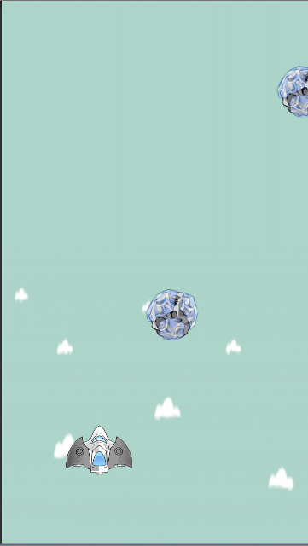

1. Collision Detection & Shooting Mechanic

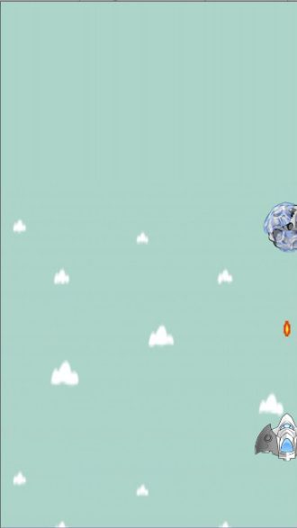

1. Player Health, Asteroid Type and Damage

